Dan Yang Yin
Dan@DansStudio.ca
Dan.studio.vancouver@gmail.com
604-537-8753
215 - 8880 Jones Road, Richmond, BC, Canada
Energetic, Rational, Passionate, Optimistic, Open-minded, Organizational

OBJECTIVE: Seeking a position for iPhone/Android Apps developement

Experience
Mobile Game Developer (Home Based)
Vancouver, B.C., Canada – 10/2009 – till now
Specific skills:
- Comprehensive experience and knowledge of developing mobile applications and games
- Ability to code on both iPhone and Android
- Established excellent understanding of logic, market demands and customers' interests of the apps
- Developed exceptional skills from 10-year experience as a musician to provide solid support to the music/sound FX for the games or applications
- Gained rich experience of drawing and painting as an artistic painter for 8 years, as well as skills of Adobe Illustrator, GIMP, Pixlr and Photoshop which enable me to provide further help to the development of games or applications

NetPortals Co. – Technical Manager
Vancouver, B.C., Canada – 07/2010 – 08/2011
Main services: Web design, Software services, Computer services
- Planning, directing, monitoring and evaluating daily operations and activities of sales department
- Designing and developing websites according to clients’ needs
- Providing internet marketing solutions such as Google Ads to maximize clients’ profits
- Accomplishing market research and trends to determine consumer demand, marketing strategy, potential sales volumes and sales target
- Generating ideas for products and services development
- Developing and implementing marketing strategies
- Implementing price and credits policies
- Communicating with potential and corporate clients

Dalian Fengyuan Technology Ltd. Co. – Senior Manager (09/2007 - 06/2010)
Dalian, China 09/2007 – 06/2010
Established in 2005, Dalian Fengyuan Technology Ltd. Co.’s primarily focus on providing installation and design of security system, smart home system and software development.
Ability to supervise: 20 including 10 full-time and 10 part-time employees.
Main projects of installation and design of security system: Dalian Polar Zoo, Dalian World Exposition Square, Sports Square Shopping Mall, etc.
- Preparing, submitting and reviewing project estimates
- Planning and preparing construction schedules
- Monitoring progress and ensuring deadlines and procedures are followed
- Establishing and implementing policies and procedures for quality control
- Planning and managing budgets, monitoring revenues and expenses
- Liaising with sales department and design department to assure well designed, profitable solutions with maximizing client’s needs and requirements
- Coordinating information and project documentation between all departments
- Overseeing analysis and reports of data and information regarding to failures of security systems in order to evaluate, review and propose recommendations for design
- Responsibility of human resource management with highly recognized skills in personnel assignment, personnel recruitment and training, and performance evaluation
- Outstanding marketing planning ability, excellent analysis and team management abilities
- Customer and results oriented

Nails & Ongle Salon – owner of 2 retail stores
Montreal, Quebec, Canada 03/2006 – 06/2007
- Planning, organizing, directing daily operations
- Implementing operational procedures
- Implementing marketing strategies and promotion activities

Education
Bachelor of Computer Application & Bachelor of Business Administration in Marketing. Concordia University, Montreal, Canada
- Special areas of emphases including VB, CSS, HTML, Management Information System , Advanced Marketing Management, Business Communication, Business Management. Solid theoretical foundation.
- Planed and organized New Year Party 2006, 2007
- Director of Student Activity Department in Student Association
(But I didn't finished the last year of the education because of moving to another city)

Personal Information
- Languages: English & Mandarin
- Excellent listening, speaking, reading, writing, translating
- Computer Abilities:
Skilled in the use of Gimp, Pixlr, Photoshop, Illustrator, Joomla, Corona, Lua, Java, FL Studio, Guitar Pro, Overtrue and web design.
- Awards:
National Archer Athletes since 2008
- Organizer / leader of the local band West37
- Drummer for 10 years
- Artist (painter) for 8 years
Samples of my designing (iPhone):
(Please notes that I am looking for a publisher to buy the copyright of those apps, so you can't download them from Apps Store now. But you can test them on my cell phone or yours during the interview.) (You can see more info and videos at my web: www.dansstudio.ca)

A restaurant game: "Early Birds"
Serve customers' orders in a restaurant, play integrated mini games as for different orders.
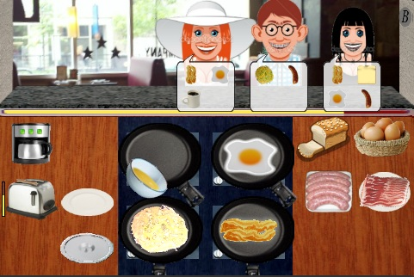
Pour coffee by moving iPhone to left angle. Accelerometer example.
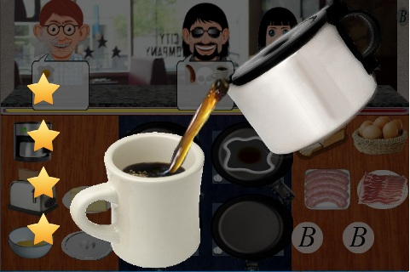
Buttering bread
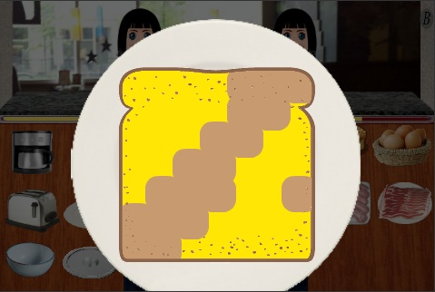

Drug the balloon whisk to beat eggs and make omelet.
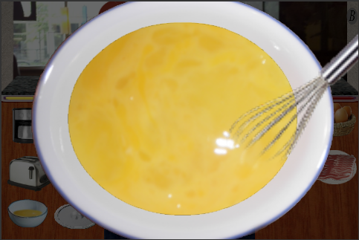

Start Combo counter and Combo sound effect by fast fulfill customers' orders.
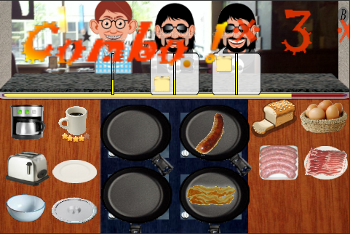

Level accomplished
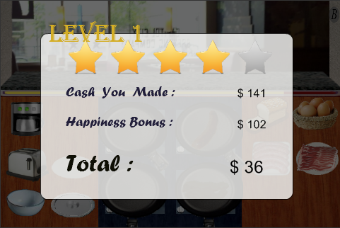

A hook and chop game: "Claw & Sword Ninja"

Hook the target with random speed, size, depth, etc.
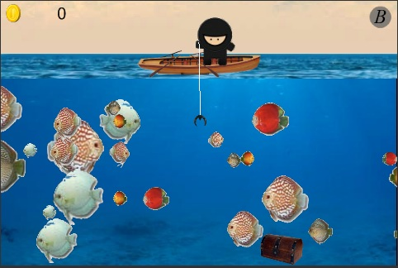

Chop target in the air like "Fruit Ninja"
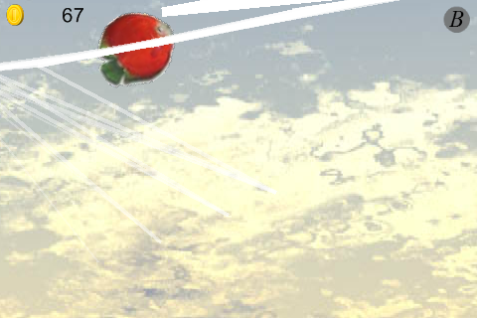

Sample of not succeed in chopping the fish
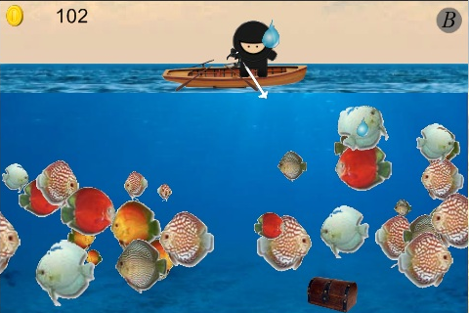

A Drum app: "Pro Auto Drum Pad"

Start menu.
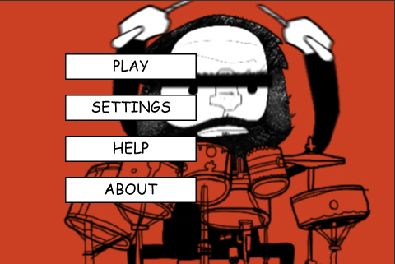

Auto play loops and fit them in to the right beat based on BPM to help the drummer's performer.
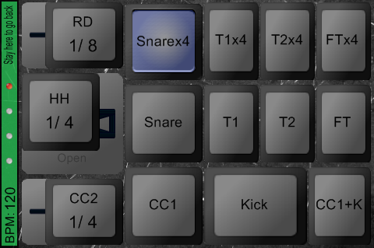

Function to save the loops and load date files in scroll list..
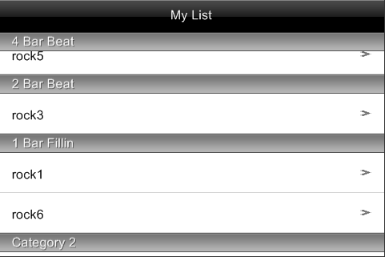
A strategy game: "Safe Breaker"

Start the game. The store where you can buy or level up items.


Mini game. An explosion animation effect.
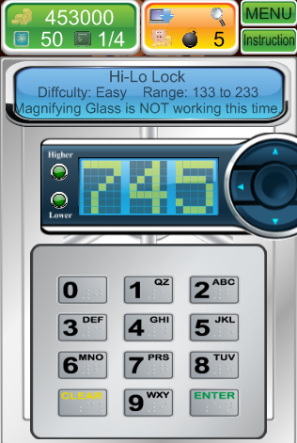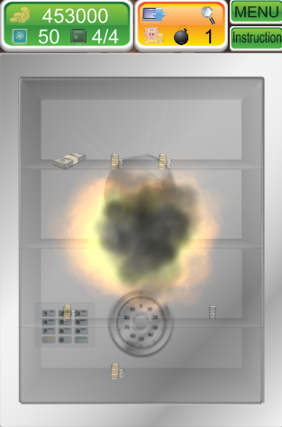

A music app: "Tempo Trainer"

Start menu. This app can generate more than 500 random loops, include guitar, bass, key broad and drum.
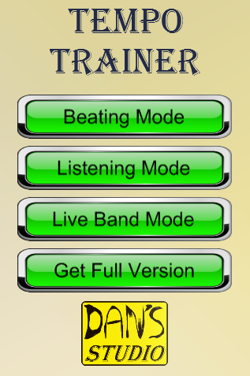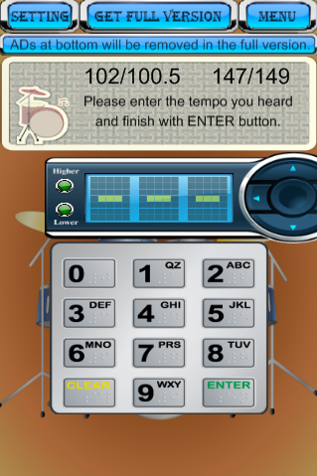

Setting menu. In game purchase function.
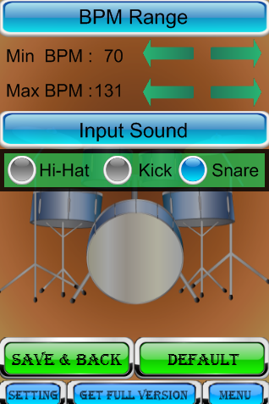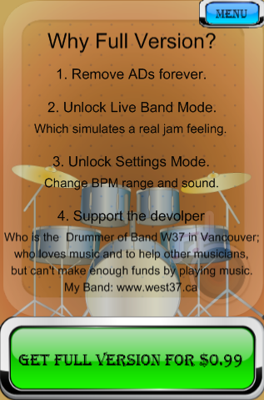

A mini game collection: " 31 GO !"
